**RINA SUBOTA**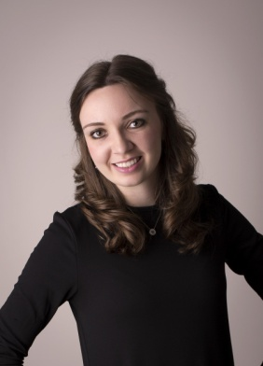

09/27/1996

Height:5’6”

**EDUCATION:**

2010-2012 Beis Aharon (Yad Yisroel)—Pinsk, Belarus

2012-2015 Bais Yaakov of Denver

2015-2016 Seminar Yerushalayim HaChadash

2016- Touro College – aiming for a degree in Speech Therapy

**WORK EXPERIENCE:**

2017- present. Secretary in Sara Schenirer Institute for Special Education—Brooklyn, NY

2016 Counselor Camp Yad Yisroel for girls – Pinsk, Belarus

2014 (Summer) Day Care Center—Brooklyn, NY

**FAMILY:**

Parents:

Vladimir Subota –Lives in Belarus, works as a radio-technology engineer at a factory.

Ludmila Subota –Passed away in 2011

Siblings:

Uri Subota –Electrician, Belarus

Sasha Hiro–Housewife, Belarus

Esther Malka Subota –Hair Stylist Toronto, Canada

**REFERENCES:**

Mrs. Meyer - BY Denver Teacher 303-960-8189

Mrs. Flam - Seminar Yerushalayim Principal 972-2-642-2607 (Israel)

Mrs. Samber - Seminar Yerushalayim Teacher 972-2-533-5434 (Israel)

R' Moshe Fhima - Head of Mosdos Yad Yisroel, Belarus 845-738- 5220 (DSL line)

Mrs. Lieba Rochel Yankelewitz - Married friend 972-52-604-1060 (Israel)

R' and Mrs. Pilchick – Close family friends 347-219-2163

Mrs. Nechama Ruth Pilchick – Boarding Family 347-563-6329

Rabbi Elazar Meisels – Dean of Sara Schenirer 347-933-5220

**FRIENDS:**

Goldie Eisig 917-689-6227

Chana Rosenberg 347-517-5123

Mazalit Behar 305-965-7196